**COMP 4910 Project Report**

**Project name:** Forestry Processor Configurator

Submitted By:

Roopkiran Kaur Sarkaria (T00541507)

Nihal Singh (T00541483)

Jiahua Huang(T00609944)

J

**Table of Contents**

**Company Overview......................................................................................................... 3**

**Project Description .........................................................................................................3**

**Requirements ................................................................................................................... 3-5**

**Analysis ............................................................................................................................. 5**

**Design ................................................................................................................................ 5-6**

**Implementation.................................................................................................................. 6-9**

**Testing** **.................................................................................................................................9-10**

**Progress Report...................................................................................................................10-11**

**Steps to use the website........................................................................................................11-12**

**Company Name:** Cypress Robotics

**Company Overview:**

Based in Kamloops, British Columbia, Canada, Cypress Robotics was formed in 2016 with the goal to revolutionize the forestry industry by reinventing processor head control systems. All their software has been designed in BC.

**Project Title**: ForestryProcessor Configurator

**Project Description:**

The goal of this project is to create a standalone, proof of concept, web application that allows potential customers to create a custom head configuration for themselves using an intuitive 3D interface. In many ways this user interface would be similar to what one may use today to customize their vehicle online before purchasing. We have created a very flexible and customizable control system. This means when customers order our processor head they can be presented with many options. The goal of this project is to enable customers to use these options without overwhelming them.

**Core Project Requirements Overview**

To be considered a successful development, the core features of this project will include:

* Understanding the scope of the project early on and creating user stories and user experience mock-ups.
* Create a proof of concept web application to demonstrate user

**Additional (Bonus) Project Features**

In addition to the core project requirements, these are some features that are desired but not required for the project to be successful:

* Create a configuration file behind the scene that contains all customer choices
* Create an instruction sheet that can be sent to production for configuring the machine based on customers choice

**Requirements**

Create a web application with

Page1:

1. A links on picture that links you to second page.
2. Slider (Pictures Scrolling)
3. Description of each machine (something like: “This is the description of first machine/processor”, “This is the description of second machine/processor” and “This is the description of third machine/processor”.

Page2:

1. Adding 3D model in the scene using three.js library.
2. 3D model of the machine 1 opens as you click picture of machine 1.
3. By declaring 3D objects to the HTML, we allow anyone to experience interactive 3D graphics as you can scroll the object and view different sides to model. Zoom in and out the model.
4. Link like Fullscreen, Exit Fullscreen and menu bar at top of the page.
5. Menu bar has side nav that have different options like main color, main saw, different machine wheels, grips, etc.
6. Drop down options for each option like main color has 2 options red and black and by clicking these options you can see the machine loading and changing color.
7. Drop down options for each option like measuring wheel has 4 options wheel 1, wheel2, wheel3 and wheel4 and by clicking these options you can see the wheel and how it loads to machine.
8. Drop down options for each option like grips has 2 options Yes and No and by clicking these options you can see the grip model load.
9. **Bonus Requirement**: Shopping centre option at the side nav from where you can select, delete and put different machines in the cart and button from where you can go back to home or default page.

**Analysis**

In this project after analysing the requirements we had to create a web application using languages like HTML, CSS, JavaScript and jQuery and were recommended by the client to use THREE.JS Library for implementing the application in order to make integration with their company website easier. The 3D data required for completing this project was provided by our 3D content specialist. Thus, we had to learn about three.js from the scratch by watching tutorial videos from internet. We also had to use WebStorm in order to load the 3D model and creating a localhost to run the application without running it directly on the browser. We had to use this because if you load models or textures from external files, due to browsers' [same origin policy](http://en.wikipedia.org/wiki/Same_origin_policy) security restrictions, loading from a file system will fail with a security exception.WebStorm is a powerful IDE for modern JavaScript development. WebStorm provides full support for JavaScript, TypeScript, HTML, CSS

**Design**

For Low Fidelity Prototype we created paper prototype which fulfill all the requirements.

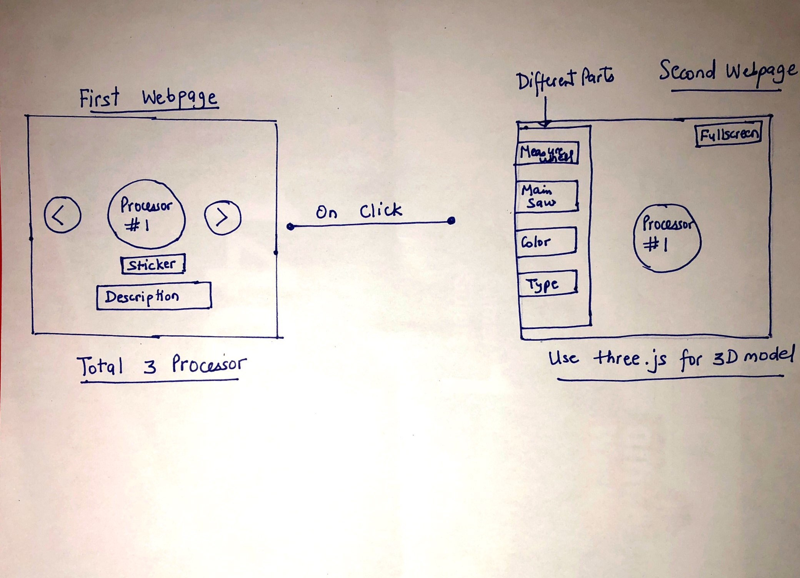

Fig1: Paper prototype

**Usability/UX goals**

* UX:
  + Satisfying
  + Helpful
* Usability
  + Simple / easy to use
  + Clean / aesthetically pleasing
  + Fast / quick to use

**Implementation**

For high fidelity prototype we had created the web application using three.js, JavaScript, HTML, and CSS and given 3D model.

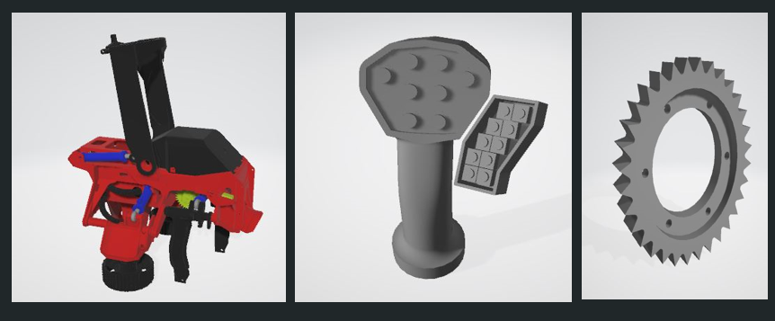

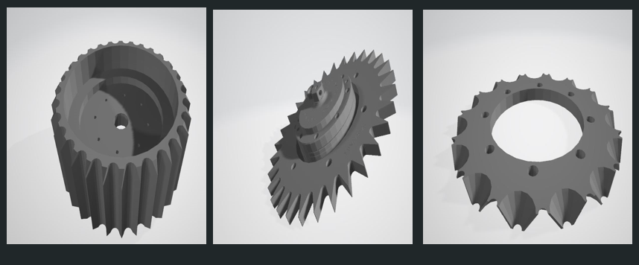

Fig2: 3D Models

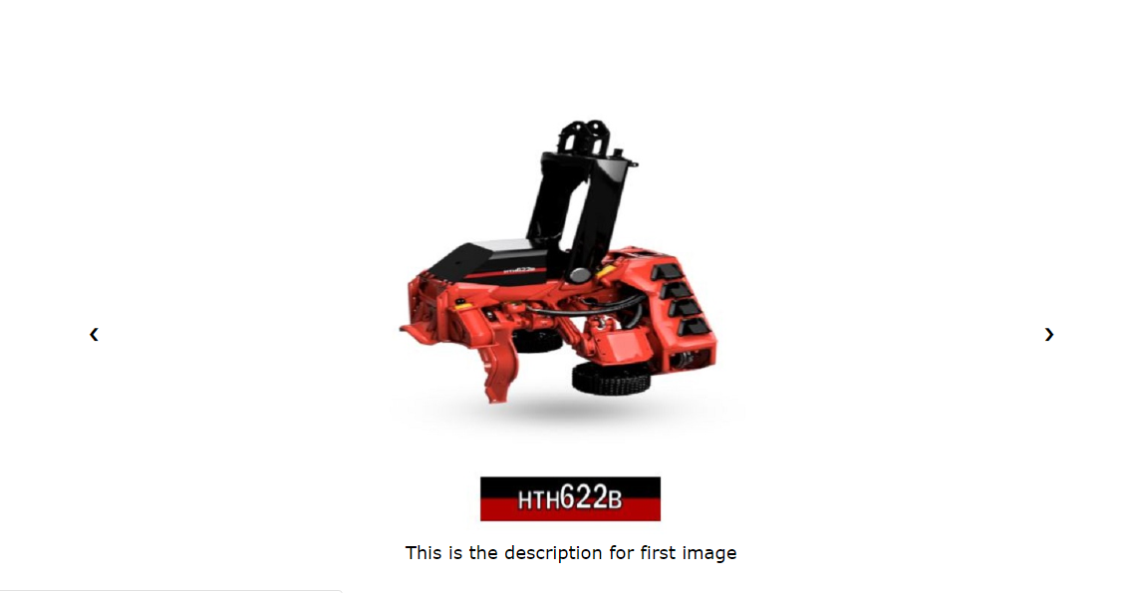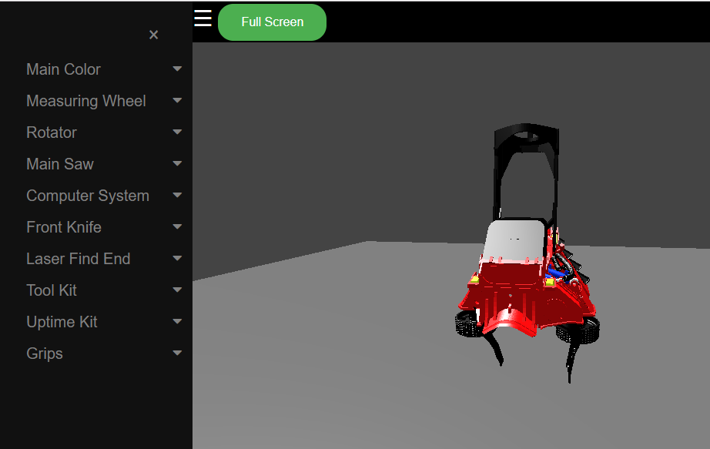

Fig3: First and Second webpage

Still changes were made in high fidelity prototype like layout reworked for ease of navigation and some more features were added like shopping center and cart (Bonus Requirement).



Fig4: First webpage

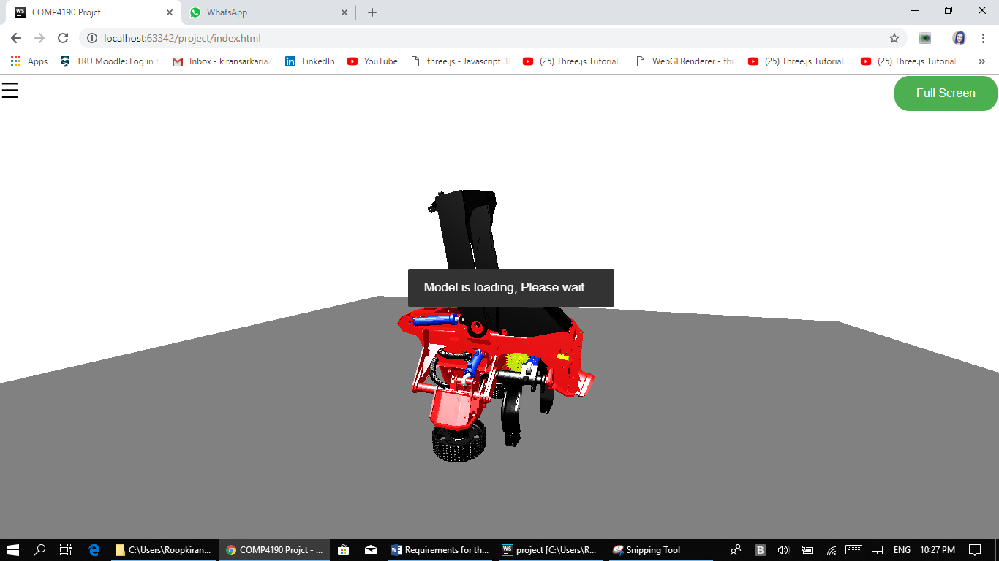

Fig5: Second webpage

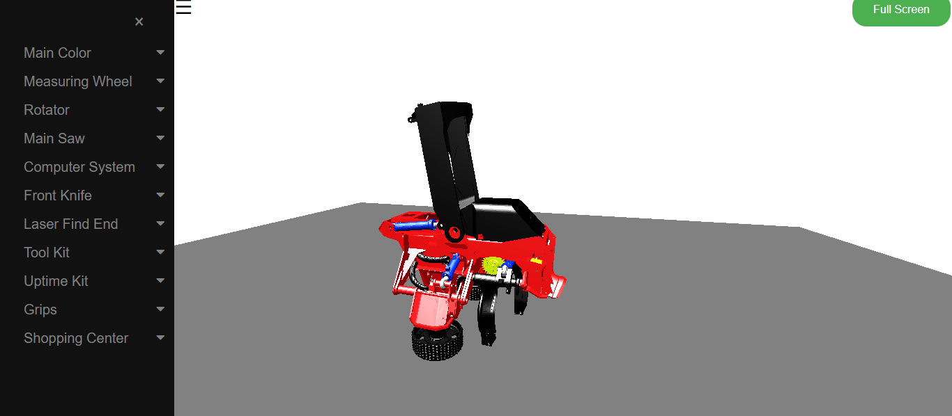

Fig6: Second webpage (Navigation Panel)

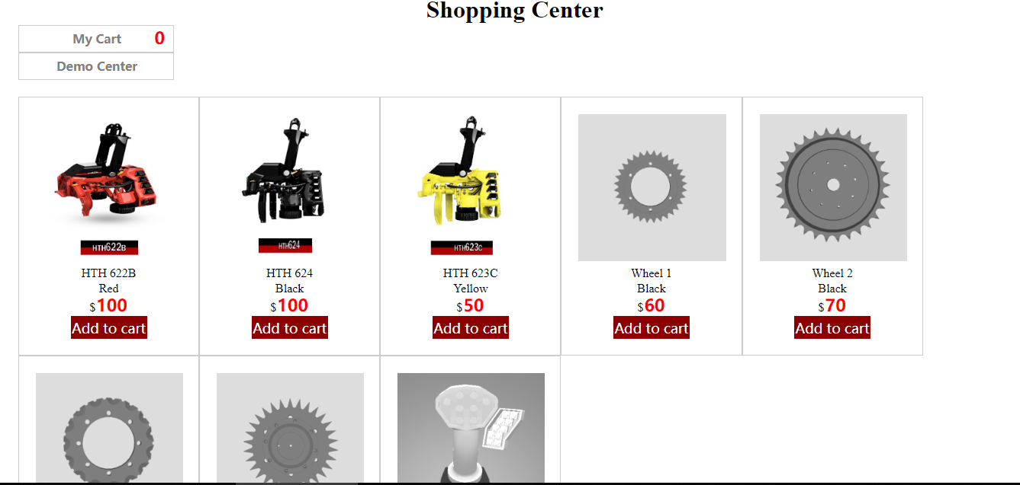

Fig7: Second Webpage-Selecting Shopping Centre Option

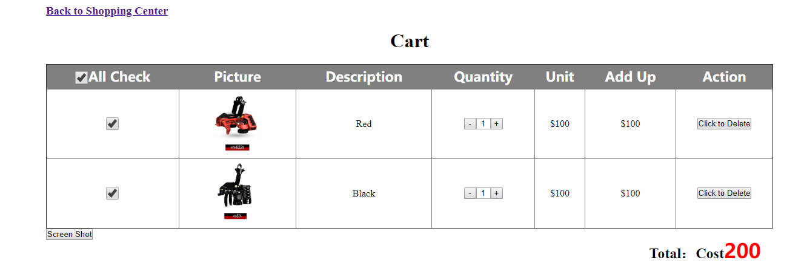

Fig8: Cart option

**Testing**

Testing is the process of evaluating a system or its component(s) with the intent to find whether it satisfies the specified requirements or not. In simple words, testing is executing a system in order to identify any gaps, errors, or missing requirements in contrary to the actual requirements. Our client has tested the application prior to its submission to evaluate it in context of the given requirements. During this project we had a lot of opportunities to test any added feature with the client as we organized a weekly meeting with the client in order to find bugs and suggestion to improve the application according to client’s needs. For the testing process we made sure that the application is device friendly with all the devices like laptop and monitor screen.

**Progress Report Summary**

Weekly report

|  |  |
| --- | --- |
| Weeks | Summary |
| Week1 | Formed our team and come with 3 team members that will do the project of “Forestry Processor Configurator”. |
| Week2 | Contacted the project coordinator to discuss about project requirements, Analysis the project requirements and tools (Three.js) that will be used to make the project. |
| Week 3 | Prepared the design layout and started making the web application using 3d model of operator provided. |
| Week 4 | Started making the first webpage of our web application using 3d models provided and figured out the layout and components that need to be shown on second webpage. |
| Week 5 | Did the first webpage of our web application and started working on second webpage. |
| Week 6 | Started making the second web page of our web application using 3d models provided and made changes to the first webpage as we were told by the client and figured out the layout and components that needed to be shown. |
| Week 7 | Uploaded the 3D models on the second webpage. |
| Week 8 | Made changes to different parts of the machinery and can customize different parts with just one click. |
| Week 9 | Finished working on the dropdown buttons on the second webpage and Add an onclick function on the dropdown options. |
| Week 10 | Met the requirement of first and second page. Everything is made according the needs of client. |
| Week 11 | Played with the layout of the second page and made changes in CSS file and Presented the midterm review in front of Instructor and the client. |
| Week 12-13 | Play with Bootstrap to make it compatible with all the devices and met the bonus requirement like cart and shopping center and add loading message. |

**Steps to use the website**

For this website to work, the client needs to have the following applications installed:

* WebStorm
* Downloaded folder where all required files are located
* Internet connection

Downloaded folder will be shared via GitHub. Here’s the link <https://github.com/jiahuah0805/COMP4190>

In order to **start the web application**, the client needs to go to the HTML folder and in it go to the file named as “**new.html**” which will **display the first web page** of the application. The first web page has links on scrolling pictures which when clicked will open the second webpage with the 3D model of the machine selected. For **editing the second web page, go to “index.html”.**

On the second webpage, we have used different dropdown options which links to different files like in **main color** we have two options: RED and BLACK**. For Red** we will use **index.html** and for **black** we will use **blackmachine.html**.

Similarly, with **red machine and Wheel**, we will use **wheel1.html, wheel2.html, wheel3.html and wheel4.html**. **For black machine and Wheel**, we will use **blackwheel1.html, blackwheel2.html, blackwheel3.html and blackwheel4.html**.

For **red machine and grip**, we have 2 option yes and no. If we select **yes**, we will use **grips.html** and for **no** we will use **index.html.**

For **black machine and grip**, we have 2 option yes and no. If we select **yes**, we will use **grips1.html** and for **no** we will use **blackmachine.html**.

Similarly, we will use **Shop.html for shopping center** and **cart.html and cart.css for cart option**.

Also, we have added comments in each html file so that the client can see what the function code does and can use that specific code in future according to their need.